ANSWERS FOR ISSSUE #2

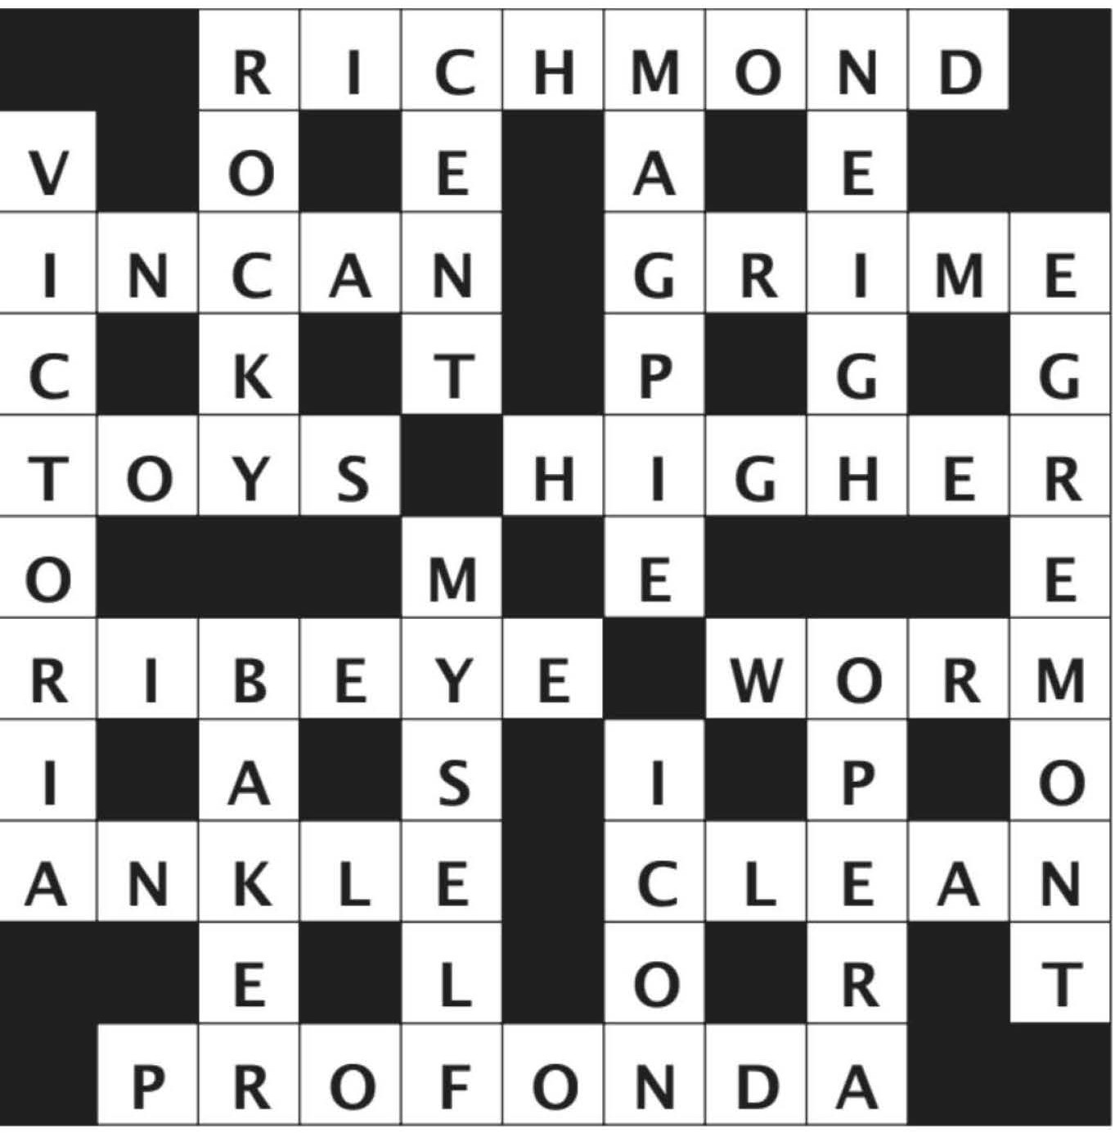

ANSWERS FOR ISSSUE #4

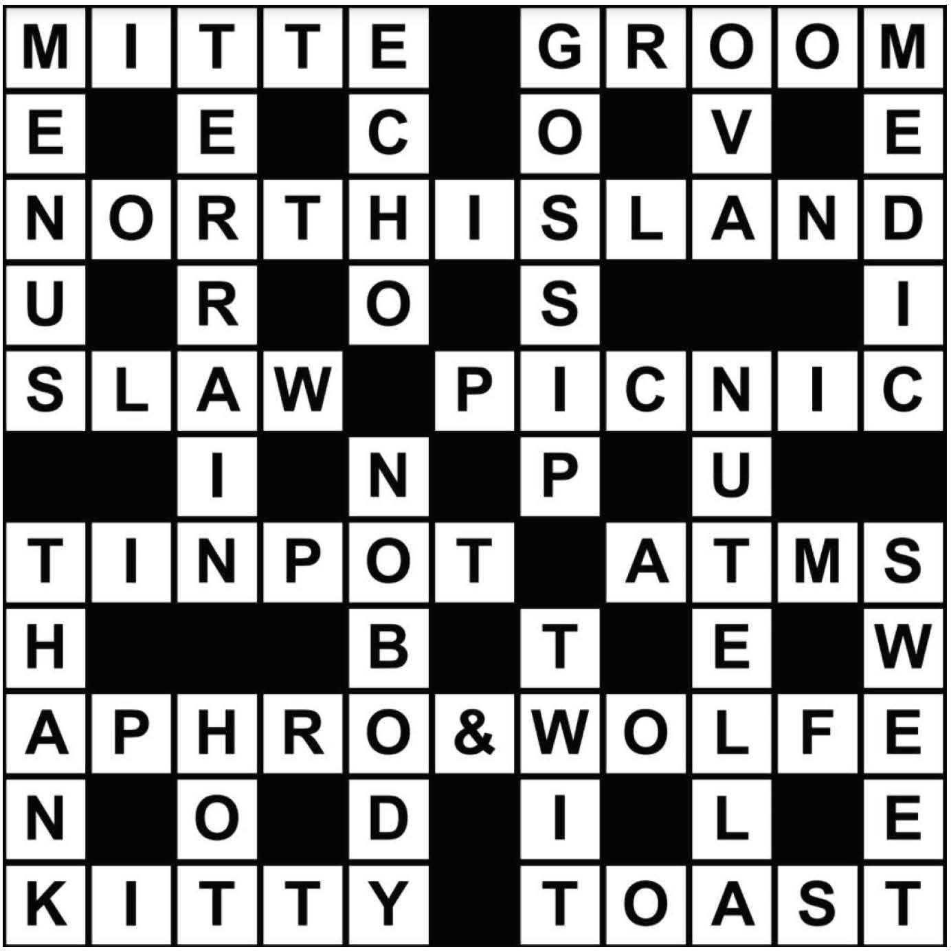

ANSWERS FOR ISSSUE #3

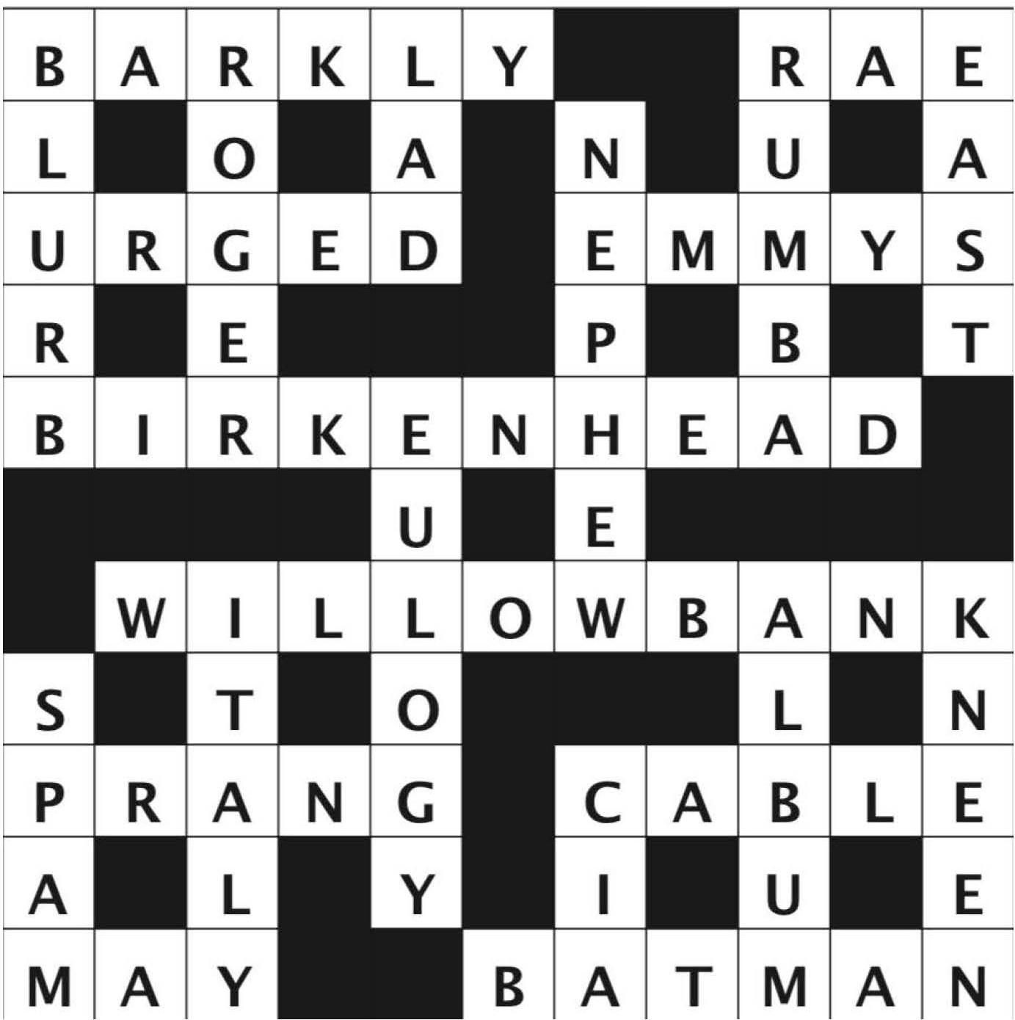

ANSWERS FOR ISSSUE #5

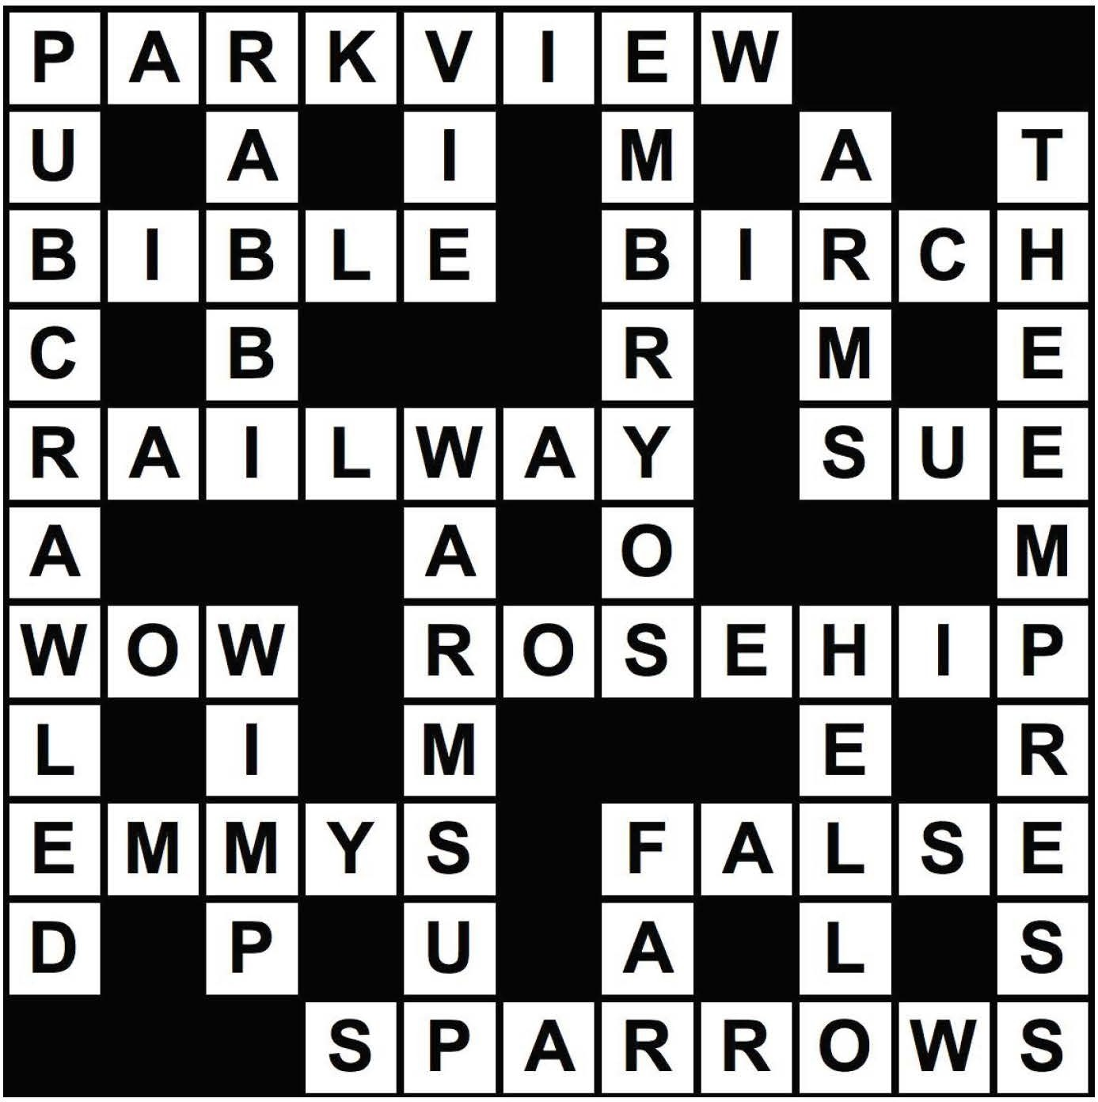

ANSWERS FOR ISSSUE #6 ANSWERS FOR ISSSUE #7

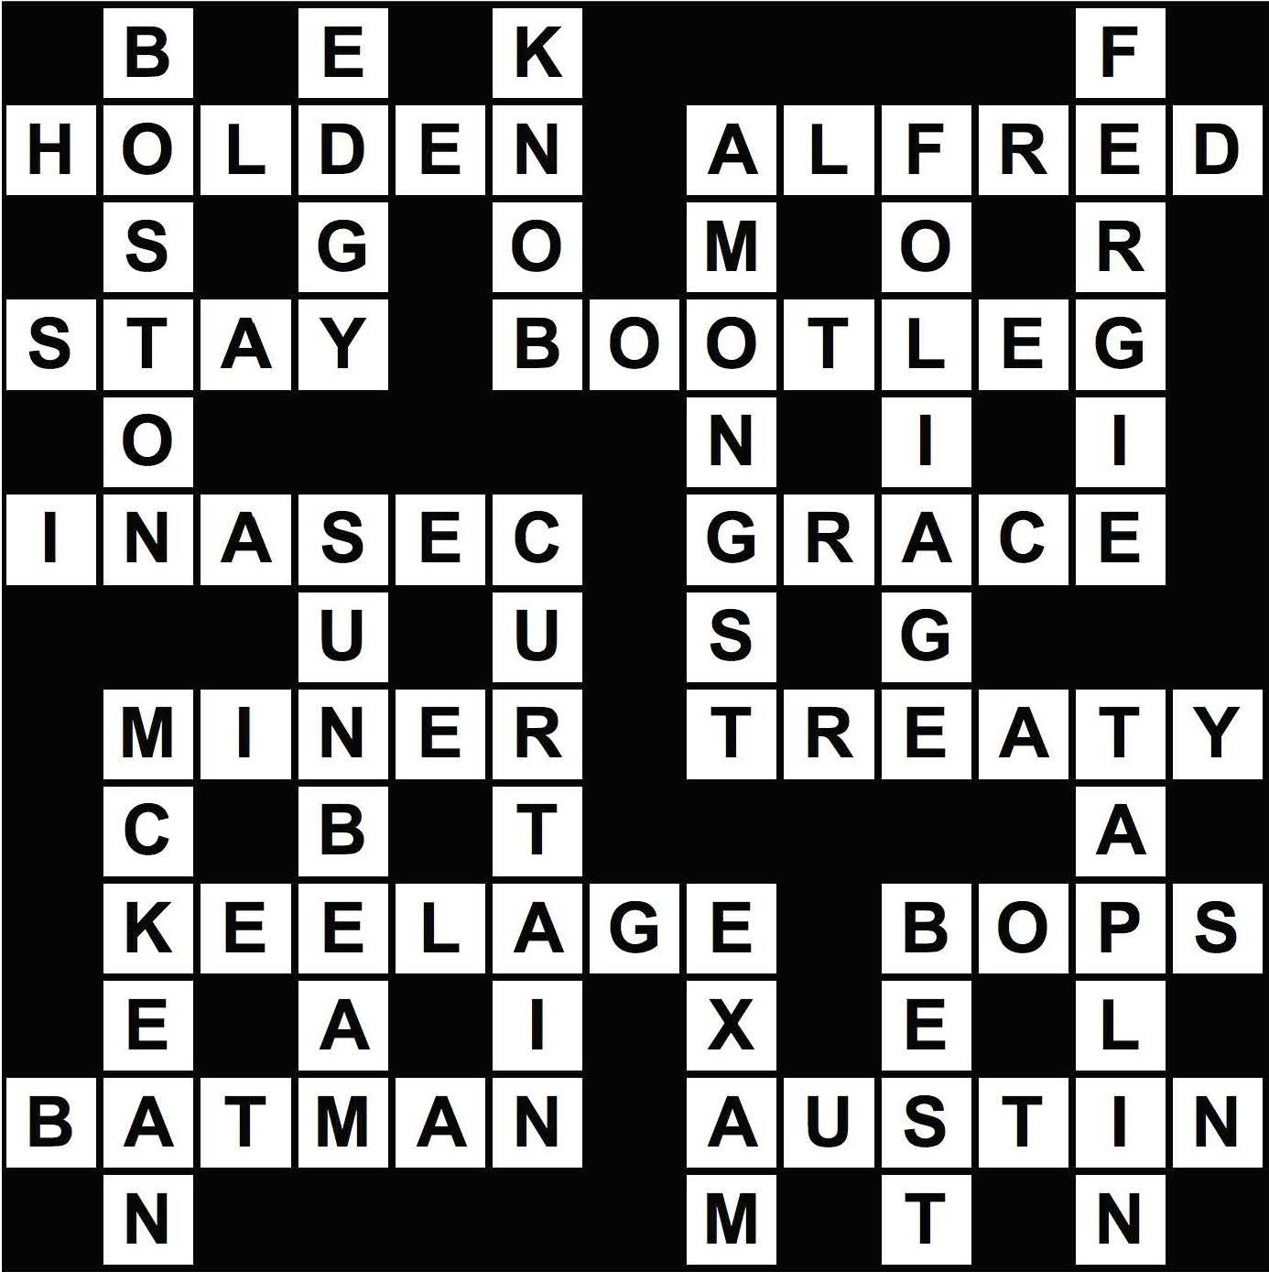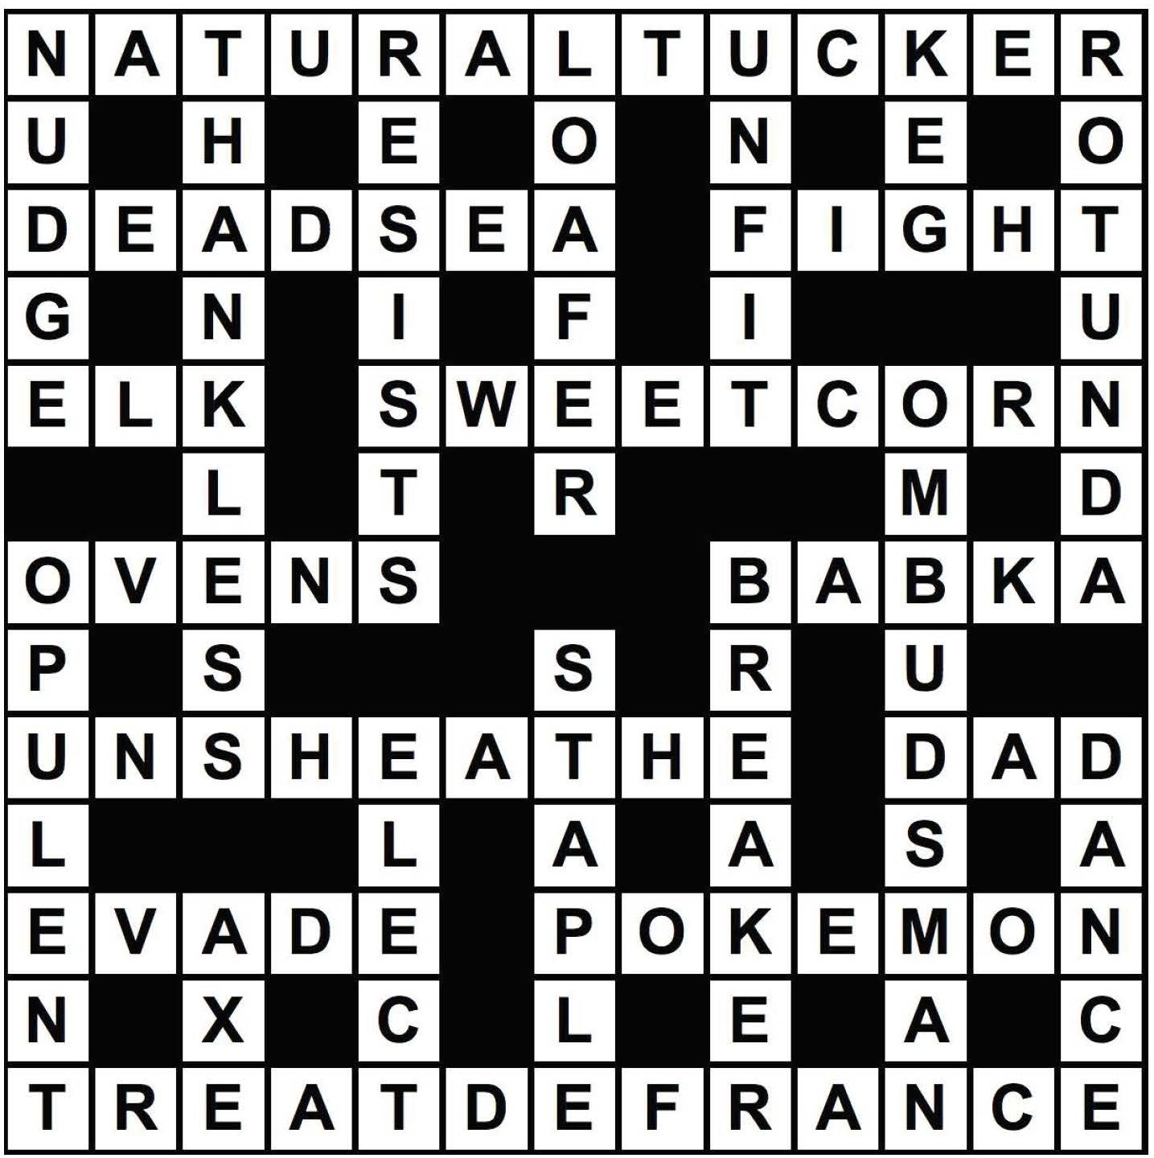

ANSWERS FOR ISSSUE #8 ANSWERS FOR ISSSUE #9

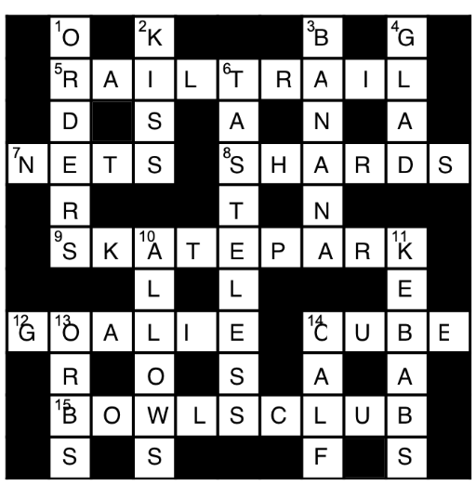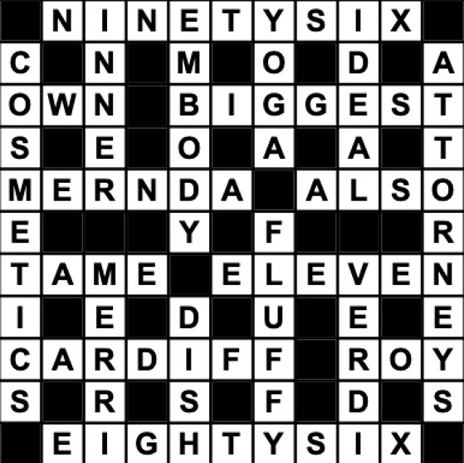

ANSWERS FOR ISSSUE #10

